UID EXPERIMENT 9
NAME: SHERIN KATHERINA D ROLL NO:240701495

AIM:
To create a simple registration form that validates username, email, and mobile number using HTML, CSS, and JavaScript.

Creating the HTML Form:

Program:
<!DOCTYPE html>
<html>
<head>
<title>Registration Form</title>
<link rel="stylesheet" href="stylesuid.css">
</head>
<body>

<div class="box">
<h2>Register</h2>

<form id="form">
<input type="text" id="name" placeholder="Username">
<input type="text" id="email" placeholder="Email">
<input type="text" id="mobile" placeholder="Mobile Number">

<button type="submit">Submit</button>
</form>

<p id="msg"></p>
</div>

<script src="scriptuid.js"></script>
</body>
</html>

OUTPUT:
A simple registration form is displayed with username, email, and mobile number fields along with a submit button.
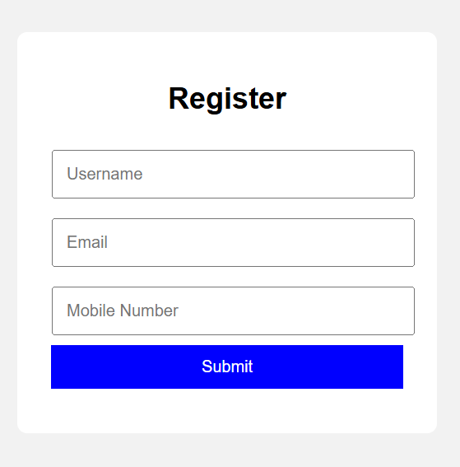

Styling the Form using CSS:

Program:
body{
font-family:Arial;
display:flex;
justify-content:center;
align-items:center;
height:100vh;
background:#f2f2f2;
}

.box{
background:white;
padding:20px;
width:300px;
text-align:center;
border-radius:8px;
}

input{
width:90%;
padding:10px;
margin:8px;
}

button{
width:95%;
padding:10px;
background:blue;
color:white;
border:none;
}

#msg{
margin-top:10px;
font-weight:bold;
}

OUTPUT:
The form appears centered on the screen with simple styling, neat spacing, and a clean layout.
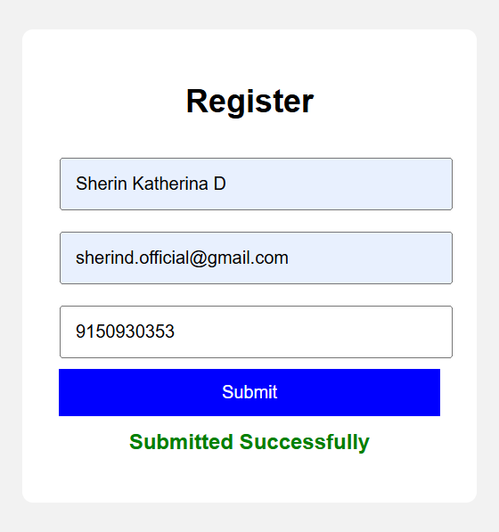

Adding JavaScript Validation:

Program:
document.getElementById("form").addEventListener("submit",function(e){
e.preventDefault();

let name=document.getElementById("name").value;
let email=document.getElementById("email").value;
let mobile=document.getElementById("mobile").value;
let msg=document.getElementById("msg");

if(name==""){
msg.innerText="Enter Username";
return;
}

if(!email.includes("@")){
msg.innerText="Invalid Email";
return;
}

if(mobile.length!=10){
msg.innerText="Invalid Mobile Number";
return;
}

msg.style.color="green";
msg.innerText="Submitted Successfully";

});

OUTPUT:
If invalid data is entered, error messages are shown. If all inputs are correct, the form is submitted successfully.
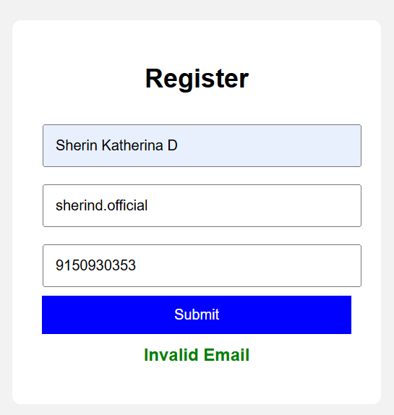

RESULT:
The registration form was successfully created and validated using HTML, CSS, and JavaScript.

CONCLUSION:
This experiment shows how validation helps to collect correct user information and improves user experience.

